**Necessary informations**

INSTITUTO TECNOLÓGICO DE AERONÁUTICA – ITA (TECHNOLOGICAL INSTITUTE OF AERONAUTICS)

LABORATÓRIO DE GUERRA ELETRÔNICA  (EW LAB)

PCA MAL EDUARDO GOMES, 50

SÃO JOSÉ DOS CAMPOS – SP – BRAZIL

12228-900

Instituto Tecnológico de Aeronáutica – ITA (Technological Institute of Aeronautics)

Laboratório de Guerra Eletrônica (EW Lab)

Pca Mal Eduardo Gomes, 50

São José Dos Campos – SP – Brazil

12228-900

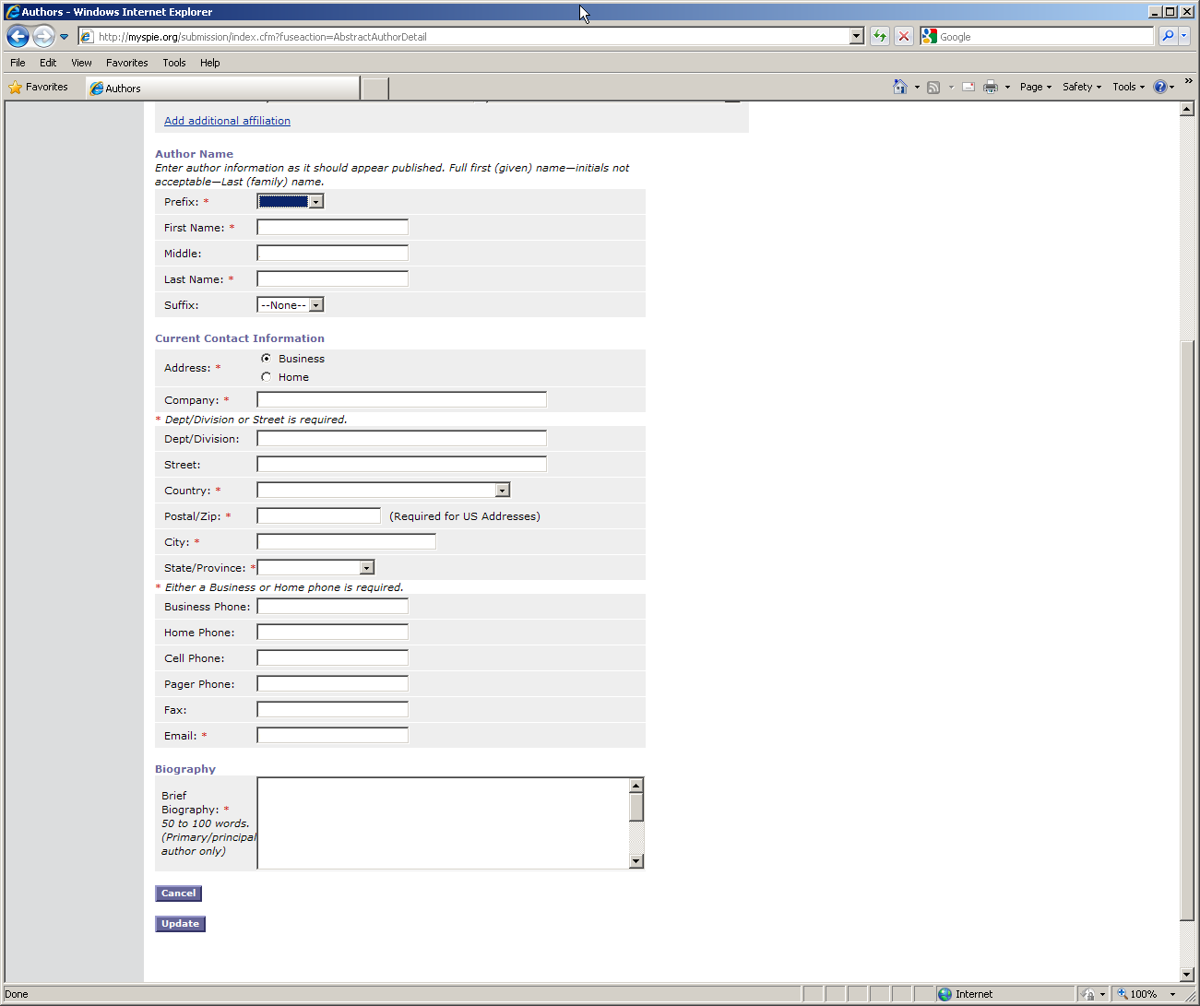

Mr.

Lester

De Abreu

Faria

Business

Denel Dynamics - DETEK

Meiring Naude Rd. (CSIR Campus), Building 43E Pretoria - South Africa – 0040

Phone (Work): 012 349 245 Phone (Work): 076 354 3948

[lesteraf@gmail.com](mailto:lesteraf@gmail.com), [Lester.Faria@deneldynamics.co.za](mailto:Lester.Faria@deneldynamics.co.za), [lester@ita.br](mailto:lester@ita.br)

Prefix: Mr

First Name: Marcio

Middle: -

Last Name: Scarpim de Souza

Suffix: none

Address: business

Company: Centro Tecnológico do Exército

Dept/Division: Laboratório de Optrônica e Sensores

Street: 28705, Americas Ave

Country: Brazil

Postal/ZIP: 23020470

City: Rio de Janeiro

State: RJ

Business Phone: +27 12 6711174

Home Phone:

Cell Phone: +27 82 5824582

E-mail: [mssouza@ctex.eb.br](mailto:mssouza@ctex.eb.br)

Prefix: Mr.

First Name: Luciano

Middle: Barbosa

Last Name: Magalhães

Adress: Business

Company: Instituto Tecnológico de Aeronáutica

Street: Praça Eduardo Gomes, 50, Vila das Acácias

Country: Brazil

Zip: 12228-900

City: São Jose dos Campos

State: São Paulo

Email: [lbmag@ig.com.br](mailto:lbmag@ig.com.br)

Biografy:

Graduation in Aeronautical Sciences, in Brazilian Air Force Force (1993-1996);

Specialization in Electromagnetical Enviroment Analisys (CEAAE), in Aeronautical Institute of Tecnology (2001-2002);

MSc in Electronic and Computing (Electronic Warfare/PPGAO), in Technological Institute of Aeronautics (2008-2009);

I have been working with aircraft and flare measurements and modeling since 2002 and have been published some papers about that.

Prefix: Dr.

First Name: Francisco

Middle: Sircilli

Company: Institute for Advanced Studies – IEAv/DCTA

Dept.: Division of Applied Physics EFA-E

Street : Trevo Cel. Av. Amarante n. 1

Country: BRAZIL

Postal ZIP: 12228-001

City: São José dos Campos

State: São Paulo

Business phone: +55(12)3947-5518

Email: [sircilli@ieav.cta.br](mailto:sircilli@ieav.cta.br) ; [fsircilli@gmail.com](mailto:fsircilli@gmail.com);